MRUnit testing

1.You need to download **apache-mrunit-1.0.0-hadoop1** which contains the Mrunit testing api.

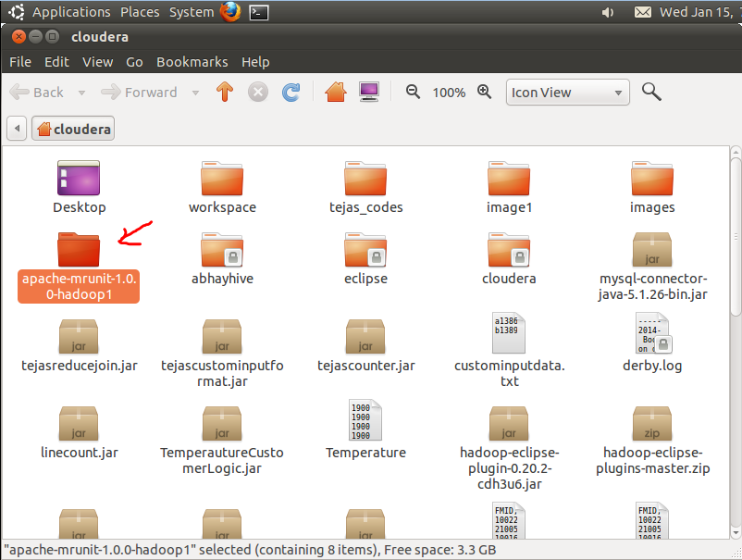

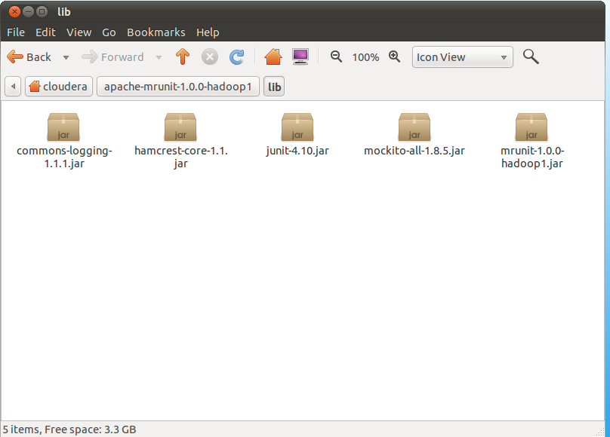

2. Import all jars from the lib folder of the downloaded file into eclipse project.

a. Right click on JRE system library

b. Select Build Path

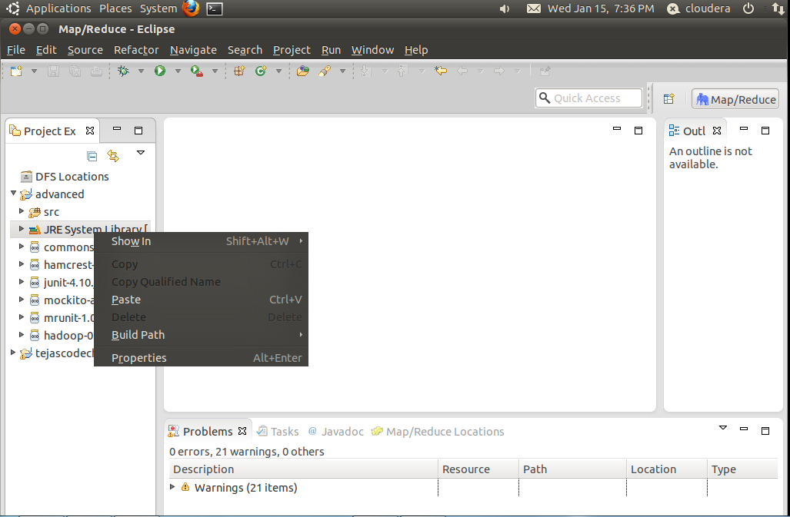

c. Select configure build path

d. Select add external jars and browse the lib folder where you have downloaded the apache-mrunit-1.0.0-hadoop1 file.

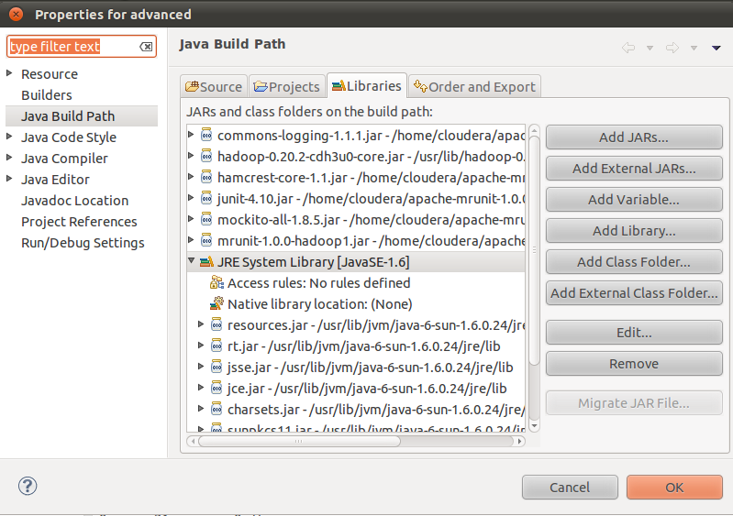

e. select all jar to add them to your testing project.

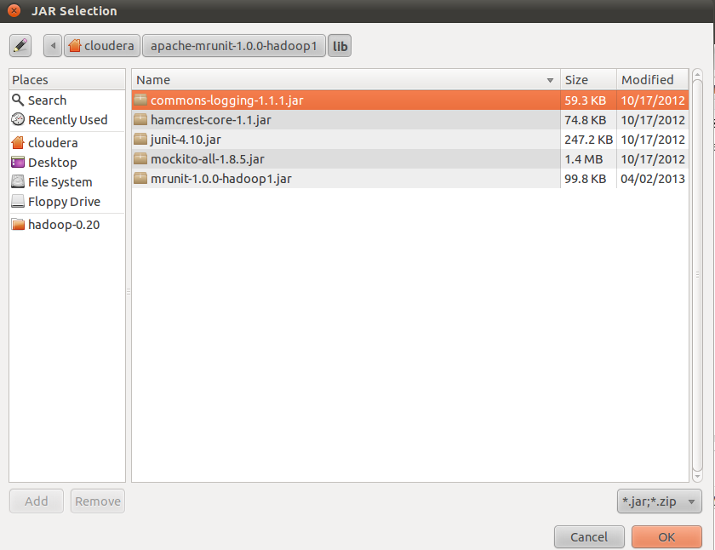

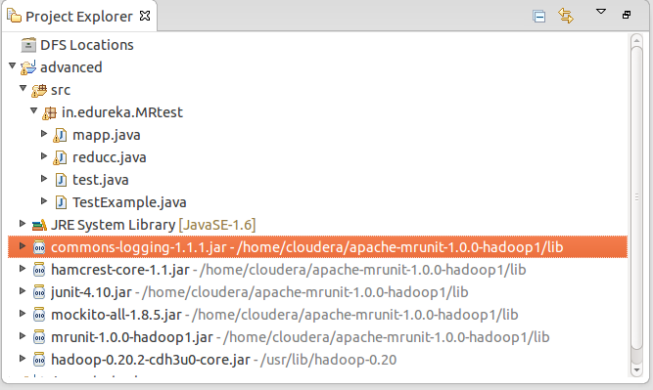

**Testing Mappers**

1. Instantiate an instance of the MapDriver class parameterized exactly as the mapper under test.
2. Add an instance of the Mapper you are testing in the withMapper call
3. In the withInput call pass in your key and input value,here LongWritable with an arbitrary value and a Text object that contains a line “First day,Sunday,abhay,holiday”.
4. Specify the expected output in the withOutput call, here we are expecting a Text object as the key with value as “Sunday” and the count of it as the value as “1”.
5. The last call runTest feeds the specified input values into the mapper and compares the actual output against the expected output set in the ‘withOutput’ method.

***Note:*** *The MapDriver only allows one input and output per test. You can call withInput and withOutput multiple times if you want, but the MapDriver will overwrite the existing values with the new ones, so you will only ever be testing with one input/output at any time.*

**The program is given below:**

import java.io.IOException;

import junit.framework.TestCase;

import org.apache.hadoop.io.IntWritable;

import org.apache.hadoop.io.LongWritable;

import org.apache.hadoop.io.Text;

import org.apache.hadoop.mapreduce.Mapper;

import org.apache.hadoop.mrunit.mapreduce.*;

import org.junit.Test;

public class TestExample extends TestCase {

public static class maptest extends Mapper<LongWritable, Text, Text, IntWritable>{

Text day=new Text();

public void map(LongWritable key,Text value,Context ct)throws IOException,InterruptedException

{

String[] line=value.toString().split(",");

int val=Integer.parseInt(line[0]);

day.set(line[1]);

ct.write(day,new IntWritable(val));

}

}

MapDriver<LongWritable, Text, Text, IntWritable> mapDriver;

public void setUp() {

new maptest();

mapDriver = MapDriver.newMapDriver( new maptest());

}

public void testMapper() {

try {

mapDriver.withInput(new LongWritable(), new Text("First day,Sunday,abhay,holiday"))

.withOutput(new Text("sunday"), new IntWritable(1))

.runTest();

} catch (IOException e) {

// TODO Auto-generated catch block

e.printStackTrace();

}

}

}